ExpressVote Marker Open Procedures
 | Before you begin, be sure you have the barrel key and Election Code.
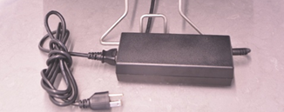 |  | - Plug in the ExpressVote power cord.
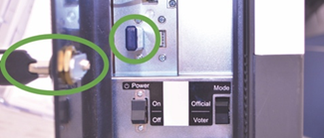 |  | - Using the barrel key, open the left side access door and verify the Election Definition flash drive is plugged in.
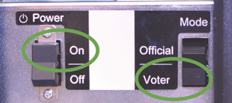 |  | - Flip the Power Switch to On and flip the Mode Switch to Voter.  Note: The system startup can take several minutes.
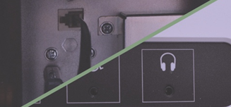 |  | - For accessible voting, plug in ADA accessories. The keypad plugs into the left side access compartment and headphones on the front of the unit.  Note: Be sure to close and lock the compartment.
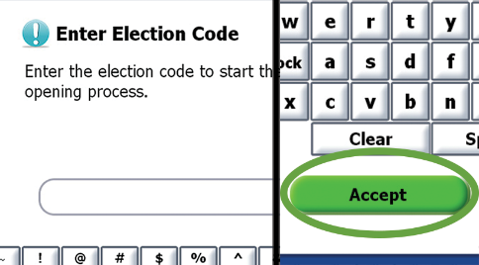 |  | - Enter the Election Code when prompted.  Then touch Accept.
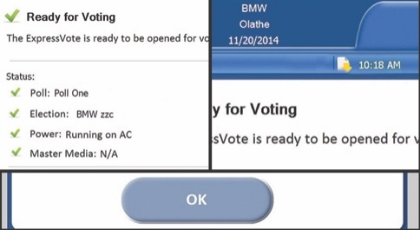 |  | - Green check marks will confirm that the unit is plugged into power and the election and poll names are accurate.  Confirm the date and time are correct at the top of the screen.  Then touch OK to display the Voter Welcome Screen.
The ExpressVote is now open.
***DISCLAIMER: These procedures are guidelines. Any requirements outlined by the jurisdiction must be followed.

ExpressVote Marker Close Procedures
 | Before you begin, be sure you have the barrel key.
 |  | - Using the barrel key, open the left side access compartment and flip the Power Switch to Off.
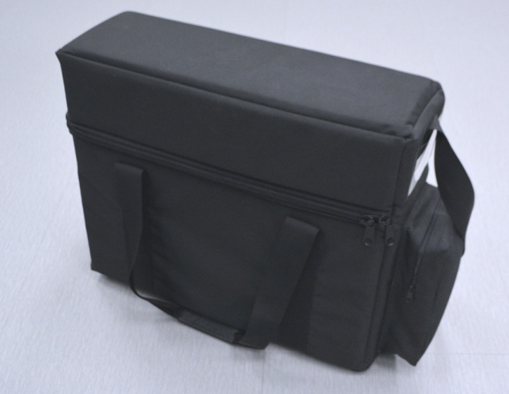 |  | - Unplug the unit, and if applicable, unplug any ADA accessories.  Note: Be sure to close and re-lock the compartment.  Return the unit and ADA accessories to the soft-sided case.
The ExpressVote is now closed.
***DISCLAIMER: These procedures are guidelines. Any requirements outlined by the jurisdiction must be followed.

