ExpressVote XL Open Procedures
 | Before you begin, be sure you have the barrel key and Election Code.
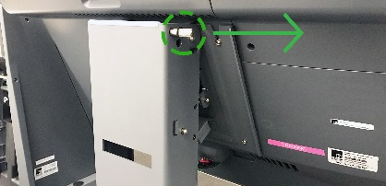 |  | - Raise the screen cover. Plug in the power cord.  To adjust screen angle, pull and remove the locking pin. Push and pull on the top and bottom of the screen to adjust, and once you have achieved the desired screen angle, replace the locking pin.
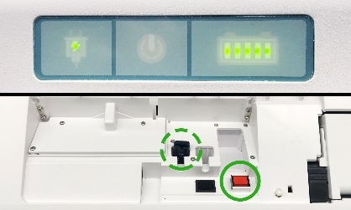 |  | - Verify the unit is connected to power – the green power indicator light will be illuminated.  Using the barrel key, unlock and open the top access compartment.  Verify the Election Definition flash drive is inserted.  Press the power button. Close and lock the top access compartment.
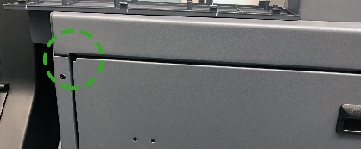 |  | - For accessible voting, plug the UVC keyboard into the USB port in the rear access compartment. For audio, plug in headphones to the UVC keyboard.  Close and lock the rear access compartment.  Note: The UVC cord threads through a notch in the top left corner of the rear access door.
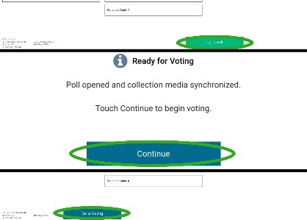 |  | - Enter the Election Code when prompted. Then touch Accept.  The Poll and Device Screen will display.  Touch Open Poll. Touch Continue.  Touch Go to Voting. The card insertion screen will display.
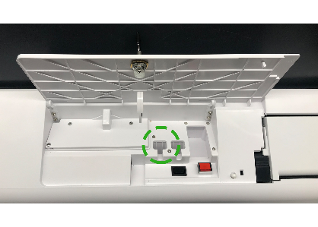 |  | - To open additional units, unlock and open the top access compartment to remove the Election Definition flash drive, close and lock the compartment and repeat steps 1-4 until all units are opened.  On the final unit, the Zero Totals Report will print.  Store reports according to your jurisdiction’s requirements.
The ExpressVote XL is now open.
***DISCLAIMER: These procedures are guidelines. Any requirements outlined by the jurisdiction must be followed.

ExpressVote XL Close Procedures
 | Before you begin, be sure you have the barrel key and Election Code.
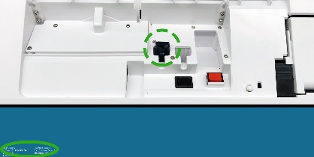 |  | - Unlock and open the top access compartment, insert the Election Definition flash drive, and close and lock the compartment.  Touch the system information panel in the lower left corner of the Card Insertion screen.  Note: If applicable, unplug ADA accessories and store appropriately, then close and lock the rear access compartment.
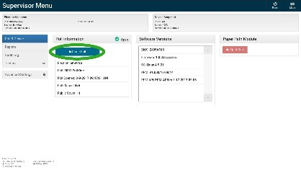 |  | - Touch Mode to switch from Voter Mode to Supervisor Mode.  Enter the election code when prompted, then touch Accept.  The Supervisor Menu will display. Touch Close Poll.
- The Election Definition flash drive is now the Collection Media.
The Device Closed and Collected screen will display, indicating the unit results have been collected.
When prompted, unlock and open the top access compartment to safely remove the Collection Media. Close and lock the compartment.
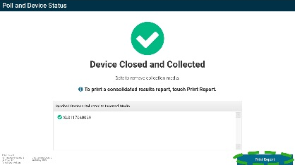 |  | - Repeat steps 1-3 on remaining units, if applicable, until all units and results have been closed and collected.  On the final unit, touch Print Report.
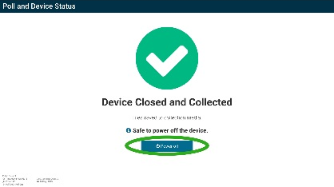 |  | - Touch Power Off, then touch Shut Down.  Store Election Definition flash drives and reports according to your jurisdiction’s requirements.  Unplug the unit and collect power cord. Return screen to upright position, lock pin in place and lower cover.
The ExpressVote is now closed.
***DISCLAIMER: These procedures are guidelines. Any requirements outlined by the jurisdiction must be followed.

