ExpressVote Tabulator Open Procedures
 | Before you begin, be sure you have the barrel key and Election Code.
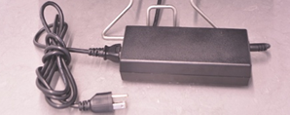 |  | - Raise the ExpressVote into voting position. Using the barrel key, unlock and open the lid, position the privacy panels, and plug in the ExpressVote power cord.  Verify the rear secure card container is empty.
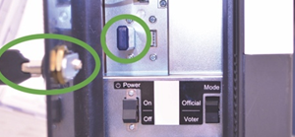 |  | - Using the barrel key, unlock and open the left side access door and verify the Election Definition flash drive is plugged in.  Flip the Power Switch to On and flip the Mode Switch to Voter.  Note: The system startup takes several minutes.
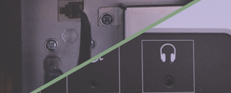 |  | - For accessible voting, plug in ADA accessories. The keypad plugs into the left side access compartment and headphones on the front of the unit.  Note: Be sure to close and lock the compartment.
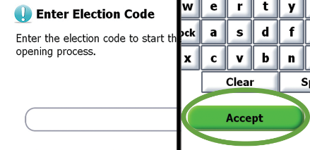 |  | - Enter the Election Code when prompted.  Then touch Accept.
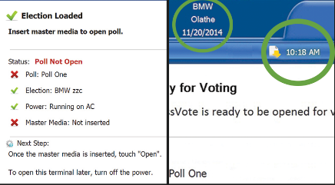 |  | - Confirm the unit is plugged into power and that the election and poll names are accurate. Green check marks display next to status items that are loaded and functioning.  Confirm the date and time are correct at the top of the screen.  Note: At this stage, the screen will read, “Status: Poll Not Open” and “Master Media: Not Inserted” with a red X.
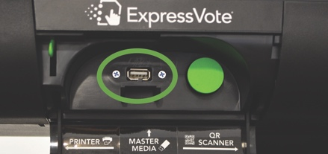 |  | - Using the barrel key, unlock and open the master media door on the front of the kiosk and insert the Master Media flash drive.  When prompted, remove the Master Media flash drive and lock the master media door.  Touch Open to finish opening the polls.
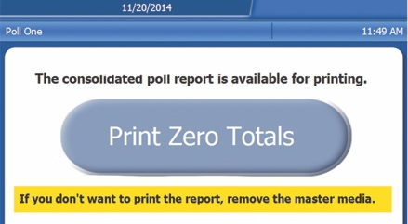 |  | - When all ExpressVote units are open, reinsert the Master Media flash drive and follow on-screen prompts to print Zero Totals report.  Remove the Master Media flash drive and lock the compartment.
The ExpressVote is now open.
***DISCLAIMER: These procedures are guidelines. Any requirements outlined by the jurisdiction must be followed.

ExpressVote Tabulator Close Procedures
 | Before you begin, be sure you have the barrel key.
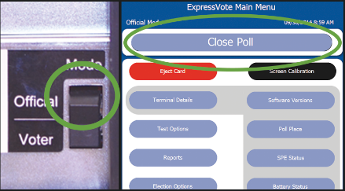 |  | - Using the barrel key, open the left side access door and flip the Mode switch to Official.  On screen, touch Close Poll, then Close.  If applicable, unplug ADA accessories and store appropriately.  Close and lock the left side access door.
- Using the barrel key, unlock and open the master media door on the front of the kiosk and insert the Master Media flash drive.
Follow the on-screen prompts.
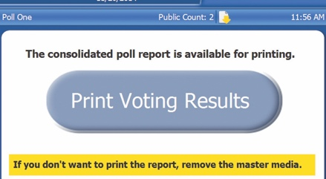 |  | - When all ExpressVote units are closed, reinsert the Master Media flash drive.  Follow prompts to print Voting Results.  After printing is complete, touch Cancel.
- Remove the Master Media flash drive and secure it along with the printed voting results according to your procedures.
Close and lock the master media door.
- Unlock and open the left side access door and flip the Power switch to Off.
Close and lock the left side access door.
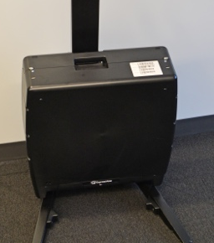 |  | - Unplug the unit and lower unit to resting position.
The ExpressVote is now closed.
***DISCLAIMER: These procedures are guidelines. Any requirements outlined by the jurisdiction must be followed.

