DS200 Open Procedures
 | Before you begin, be sure you have the Election Code, barrel key and ballot box key.
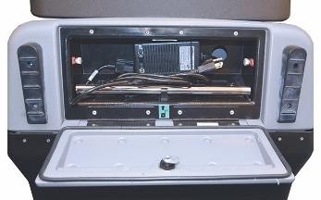 |  | - Using the ballot box key, unlock the back door and plug in the power cord.  Using the ballot box key, unlock and confirm the auxiliary and main ballot compartments are empty.  Lock the auxiliary and main ballot compartments.
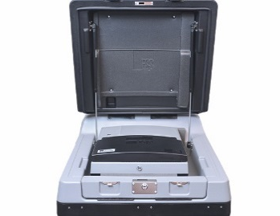 |  | - Using the ballot box key, unlock and open the ballot box lid.  Using the barrel key, unlock and gently lift the screen. The DS200 will power up automatically.  Note: If the DS200 does not power up upon lifting the screen, use the barrel key to unlock the left side access door and press the Power button.
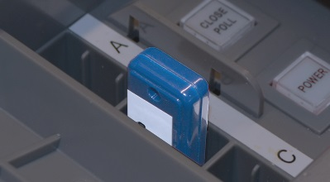 |  | - Using the barrel key, unlock and open the left side access door and insert the Election Definition flash drive.  When prompted, enter the Election Code.
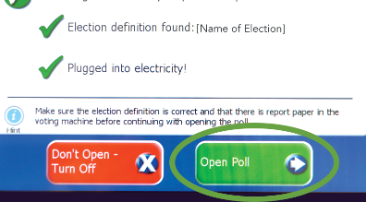 |  | - The Configuration Report will automatically print.  Green check marks will confirm that the Election Definition is found, and that the unit is connected to power. Then touch Open Poll.  Note: If the Election Definition shows “not found” and doesn’t have a green check mark, make sure the Election Definition flash drive is pushed in all the way.
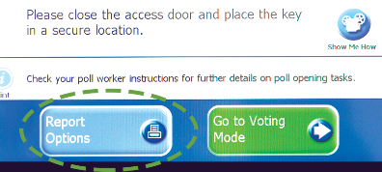 |  | - Status and Zero Totals reports will automatically print.  If you need to print additional reports, or a report does not print correctly, touch Report Options.  Note: Follow your procedures for securely handling the Zero Totals report.
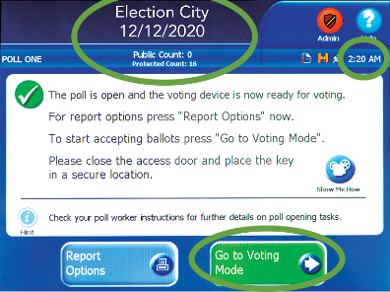 |  | - Confirm the Public Count is zero.  Note: Call Election Central for assistance if Public Count is not zero.  Confirm the date, time, election and poll names are correct.  Touch Go to Voting Mode.
The DS200 is now open.
***DISCLAIMER: These procedures are guidelines. Any requirements outlined by the jurisdiction must be followed.

DS200 Close Procedures
Before you begin, be sure you have the Election Code, barrel key and ballot box key.
If applicable, check the auxiliary ballot compartment for ballots, and follow your jurisdiction’s rules on handling those ballots.
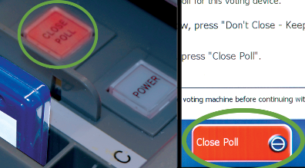 |  | - Using the barrel key, unlock the left side access door and press the  Close Poll button. It will blink red.  On screen, touch Close Poll.  Close and lock the left side access door.
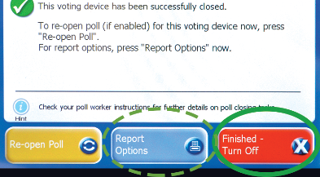 |  | - Depending on the configuration of the Election Definition flash drive inserted, Voting and Write-In Results may automatically print.  If you need to print additional reports, touch Report Options.  Touch Finished - Turn Off after reports are done printing.
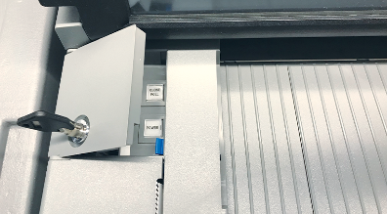 |  | - Using the barrel key, unlock the left side access door.  The power button will change from green to red.  When it is no longer lit, remove the Election Definition flash drive and lock left side access door.  Note: Do not remove the Election Definition flash drive when the power button is still lit.
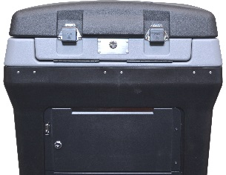 |  | - Follow your procedures to securely store the Election Definition flash drive and any printed reports.
- Unplug and return the power cord.
Using the ballot box key, close and lock the back door.
Close the screen and using the ballot box key, lock the ballot box lid.
The DS200 is now closed.
***DISCLAIMER: These procedures are guidelines. Any requirements outlined by the jurisdiction must be followed.

